A guide to making an NHS or Social Care complaint

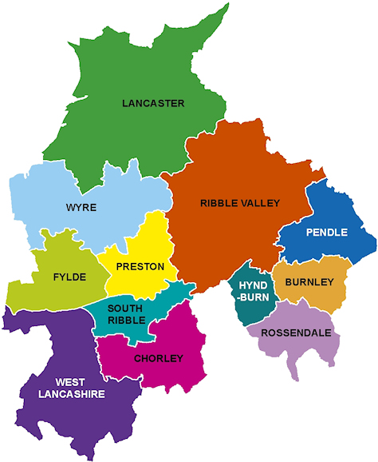

Introduction:
If you are unhappy with any service you have received from an NHS or Social Care provider you are entitled to raise your concerns about it. You also have the right to be listened to and treated with respect and dignity throughout the process.
There are some examples below of what you can make a complaint to the NHS and Social Services about;
Doctors and Nurses Dentists Hospital and Staff

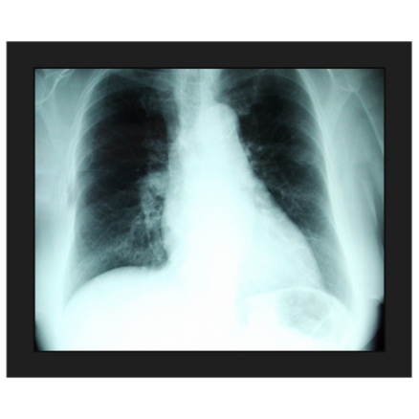
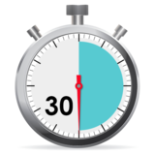
Medication Errors Misdiagnosis Waiting Times

Social Workers Care Coordinators

Raising your concern could potentially resolve the issue or provide you with an explanation and/or an apology. Sharing your experience with the NHS or Social Services can also be beneficial to them as they can use your experience to improve the treatment and care they provide for others in the future.
This document has been designed to guide you through the complaint process, step-by-step. Its aim is to provide you with the relevant information you need to progress with your complaint, the different options available to you, information about how an advocate can support you and ultimately, to make you feel more confident about raising your concerns.
You can also make a complaint on someone else’s behalf, however, consent will need to be gain from the individual you are complaining on behalf of (exceptions apply for those that are deceased or if they lack capacity to consent themselves).
Throughout this document you will find information and tips which you may find useful to refer back to as you progress through the complaints process.

How can Advocacy Focus help you with your complaint?
Advocacy Focus is an independent, free and confidential service. This service is designed to support anyone who feels they cannot initiate and complete a formal complaint alone. We can support you through the NHS or Social Care complaints process if you reside in the Lancashire area.
Your advocate can:
- Provide a confidential and independent service for you to discuss your complaint with
- Explore the different stages of the complaints process with you
- Help you to format and compose any letters you wish to send in relation to your complaint
- Assist you to prepare for and attend any resolution meetings you are asked to attend
- Assist you to escalate your complaint if you are not happy with any responses that you receive
It is important to understand that your advocate cannot advise or influence your decisions in any way and that they are there to provide you with information and the possible options, not their own opinions. Support can be accessed over the telephone, email or by a face-to-face meeting with an advocate and can be provided at any stage of the complaints process.
Our details are as follows;
Advocacy Focus
The Old Tannery Building
Eastgate
Accrington
Lancashire
BB5 6PW

Telephone: 0300 323 0965
Text: 07886 744 634
Email: admin@advocacyfocus.org.uk
Website: www.advocacyfocus.org.uk
Before You Make Your Complaint:
It is important that you take some time to think exactly what it is you are wishing to make a complaint about. This may be one particular event or a number of different elements regarding your care and treatment.
Both the NHS and Lancashire County Council request that complaints are made as soon as possible but no longer than twelve months after the date of the event or twelve months from when you became aware that you needed to make a complaint.
As your complaint may have numerous elements to it, it may be useful to use the box below to separate each issue:

What Outcome Are You Hoping To Achieve?
There are various outcomes that can be achieved from making a complaint, such as;

- An explanation
- An apology
- Changes to be made to policy and procedures

There are also things that cannot be achieved through making a complaint, such as;

- Financial compensation
- Disciplinary action

If you are hoping to achieve financial compensation this can only be achieved through taking legal action. You will need to seek advice from a solicitor. If you do decide to take this route it is important that you involve a solicitor as early as possible.
Disciplinary action may come as a direct result of your complaint being investigated by the NHS or by Social Services, however, this is not a guaranteed outcome as it is dependent on the policies and procedures of the organisation. The organisation is not obliged to inform you if disciplinary action comes as a result of the complaint.
It might be useful for you to think about what outcome(s) you are hoping to achieve through making your complaint and any questions you’d like answering:

Raising Your Complaint:
There are many different ways to make a complaint, whether this be formal or informal. If you feel comfortable you can speak to a member of staff or their manager directly. This is usually the quickest way to resolve a problem and prevent it from escalating further. If, however, you do not feel comfortable doing this you could speak to the Patient Advice and Liaison Services (PALS) if you are complaining about the NHS.
What is PALS?
The Patient Advice and Liaison Service (PALS) offers confidential advice, support and information on health-related matters within the NHS. They provide a point of contact for patients, their families and their carers.

PALS provides help in various ways:
- Help you with health-related questions
- Help resolve concerns or problems when you’re using the NHS
- Tell you how to get more involved in your own healthcare
PALS can give you information about:
- The NHS
- The NHS complaints procedure, including how to get independent help if you want to make a complaint
- Support groups outside the NHS

PALS can help to improve the NHS by listening to your suggestions.

Following the Relevant Complaints Procedures for NHS and LCC
You may feel that making a formal complaint is the best option for you. This may be because:
- You have raised the issue with a member of staff but still feel the issue has not been resolved
- You do not feel comfortable raising the issue directly with a member of staff
- You feel the complaint requires an investigation
- Your complaint has numerous elements to it
The NHS advise that you should complain directly to the service provider first, for example, the GP, dentist, hospital, etc. Alternatively, you can complain to the commissioners of that service – either NHS England or the areas Clinical Commissioning Group (CCG). In general, NHS England commissions most primary care services, such as a GP, dental services, opticians and pharmacy services. CCGs oversee the commissioning of secondary care, such as hospital care and some community services. If you are unsure who you need to make a complaint to you can contact NHS England (Lancashire) on: 01772 420150
You can make a formal complaint to the NHS in the following ways:
- In person
- On the telephone
- Using e-mail
- You can write a letter to them
You can make a formal complaint to Lancashire County Council (LCC) in the following ways:
- Using their ‘Your View Counts’ leaflet
- You can make a complaint at www.lancashire.gov.uk
- You can contact them on 0300 123 6720
- You can write a letter to them

Template Complaint Letter
Should you choose to write a complaint letter, it is advised that you keep a copy of any correspondence you send so you can refer back to it at any point.
Below is a template that can be used when writing your complaint;
Your Name
Address
Telephone

The Complaints Manager
Name of the organisation or trust
Address of the organisation

Date

PRIVATE AND CONFIDENTIAL

To Whom It May Concern (or Dear [Name] if you know it),

I am writing to complain about the treatment I received from [name of staff or people involved] at [name of the service or the place where the incident happened] on [date of incident or time period].

Now describe what happened, when and where. The more specific your information the easier it will be for the Complaints Team to deal with your complaint.

Explain what you have done, if anything, to attempt to resolve the issue already. For example, this could be a direct conversation you have had with the member of staff involved. Try to include dates, names and locations where you can.

I would like you to respond to the following points of my complaint:
- Put here all the specific points that you are unhappy with, with the most important first.

In your response, I would like you to answer the following questions I have:

- Here you should ask specific questions you would like answered about the incident or the treatment you are unhappy with.

As a result of this complaint, I would now like (this is where you put the outcome you want to achieve), e.g.:

- An explanation of what happened and why
- An apology
- Action to remedy the problem or change things so that this does not happen again in the future

I would be grateful if you would please carry out a full investigation into my concerns and provide me with a response in line with the NHS Complaints Procedure.

Yours sincerely should be used if you know the name of the contact and yours faithfully if you don’t.

Your signature

Print your name

If you would like other people to receive the response also, put this here, e.g.:

Cc. John Smith
[Name of service and address here]

What Happens Next?
- Whether your complaint is to the NHS or LCC you should be sent acknowledgement of your complaint within three working days. The acknowledgment letter should let you know approximately how long it will take for them to investigate and reply to your complaint. The letter will generally ask you to contact them again if you haven’t heard by that deadline.
- By the end of the deadline you should receive a response to your complaint letter. Their response should answer he issues you have raised and whether or not the outcomes you expect can be met. If you haven’t received a response by this time another letter or phone call would be appropriate.
- If you don’t agree with the response you can write another letter back to them, similar to your original complaint detailing your issues with the response or you can also ask for a resolution meeting.
On asking for a resolution meeting (either by telephone, email or letter) you should detail the issues you don’t feel have been resolved so far in the complaints procedure. This will take place with those involved either at the NHS or LCC. You do not have to attend this meeting on your own and you should be offered a time and date that is suitable for you.
If you feel you do not have a family member or friend that is suitable to attend this meeting with you, or you feel an advocate would be more appropriate then please contact Advocacy Focus on 0300 323 0965.

Resolution Meetings:
A resolution meeting provides an opportunity for the organisation to answer any questions you may have and provide further information or explanations face-to-face. Formal meetings can often feel daunting so we’ve made a list of things you may which to discuss:
Have to hand:
- A list of issues you would like to discuss

- The outcomes you would like to the issues being discussed. Please note that having more than one outcome may give you a better chance of getting what you want

Be prepared to wait for the response to the resolution meeting, especially if they have to investigate further.
Resolution meetings sound intimidating but generally, although they are formal, are friendly environments and those dealing with the meeting will have a lot of previous experience of chairing them.
What happens during a resolution meeting:
- The meeting will be run by the NHS department or Lancashire County Council office. They should offer introductions as it is important that you know who is in your meeting and what role they will be playing

- During the resolution meeting each unresolved issue or outcome should be dealt with and discussed. You will also be given the opportunity to raise any more questions that may have arisen as a result of the meeting

- At the end of the meeting some or all of your issues may have been addressed. If not, sometimes there may be a need for either the NHS or Lancashire County Council to investigate the matter further. You can ask at this point for a letter to be written or another resolution meeting if this is easier

- Once complete you will receive a letter or an invite to a further meeting detailing the issues or outcomes raised and the decision as a result of further investigation

If you feel your complaint hasn’t been dealt with appropriately or suitably then you can take this to either the Parliamentary and Health Service Ombudsman or the Local Government Ombudsman depending on who the complaint is about.

The Parliamentary and Health Service Ombudsman (PHSO):

If your complaint was regarding an NHS funded service and could not be resolved at the local resolution meeting you have the right to appeal to the Parliamentary and Health Service Ombudsman (PHSO). The PHSO will not investigate your case further if you have not tried to resolve the issue at the local resolution level. It is important to also note that the PHSO will look at each individual case that is sent to them, however, they are not obligated to investigate them all.

Again, the complaint should be submitted no later than one year after the event or incident you are complaining about or from the date you first became aware of the matter. There are certain circumstances where this rule may not apply, for example, if you have been unwell or the local resolution lasted more than a year.

They also have a helpline if you would like to discuss your complaint with someone before submitting it to see if your complaint hits the criteria and they will accept your complaint:

0345 015 4033
8.30am - 5.30pm Monday to Friday

You can complain to the PHSO using the following link:

https://www.ombudsman.org.uk/

On this website you will be able to access their complaints form, along with a guide on how this should be completed. They also have a helpline and easy-read and large-print documents available for download. If you do not have access to a computer and would like some support with this, then please contact Advocacy Focus to speak with an advocate.

The PHSO Process:

Step 1:

When the Ombudsman receives your complaint they will first check it for eligibility. They will check:

- Whether they can look into organisation you are complaining about
- You have been through the complaints process of the organisation you are complaining about

Timescale: The PHSO aim to complete these checks within five working days.

The PHSO receive approx. 29,000 complaints a year and roughly 25% of these progress to the next stage. If they can't take your complaint forward, they will give you information about what you can do next.

Step 2:

When the PHSO are deciding if they should investigate your complaint further they will look at:

- Whether you have been affected personally by what happened
- Whether you complained (to them or an MP) within a year of knowing about the issue
- Whether you have (or had) the option of taking legal action instead
- Whether there are signs that the organisation potentially got things wrong that have had a negative effect on you that hasn’t been put right

Timescale: The PHSO aim to give you a decision within 20 working day.

The PHSO consider over 8,000 complaints a year at this step. They go on to investigate around half of these. If they decide not to investigate your complaint, they will explain why. If there are other options open to you, they will let you know what these are.

Step 3:

The next stage in the process is for an investigation to be completed by the PHSO. An Ombudsman representative will be allocated your complaint and they will talk to you about your concerns and what they are going to investigate. They will tell you how long they think their investigation will take and keep you regularly updated. They will gather all the information they need, including from you and the organisation you have complained about, before they make their final decision.

Timescale: The PHSO will aim to complete most of the investigations within a three-six month period. Some investigations make take longer than this, however, they aim to complete 98% of them within a year.

If the PHSO uphold your complaint it means that they have found the organisation have got things wrong which has had a negative effect on you and which hasn’t been put right. They can recommend what the organisation should do about this.

They investigate around 4,000 complaints a year and uphold, in full or in part, around 40%.

The Local Government Ombudsman (LGO):

The Local Government Ombudsman is the final stage for complaints about councils and some other organisations providing local public services. They look at complaints about adult social care providers (such as care homes and home care providers).

The LGO state that you should go through all stages of the organisation’s complaints process. If the complaint has not been resolved, or you have not had a response within a reasonable time, you can take your complaint to the LGO.

Again, the complaint should be submitted no later than one year after the event or incident you are complaining about or from the date you first became aware of the matter. There are certain circumstances where this rule may not apply, for example, if you have been unwell or the local resolution lasted more than a year.

You can complain to the LGO using the following link:

http://www.lgo.org.uk/

They also have a helpline if you would like to discuss your complaint with someone before submitting it:

0300 061 0614
8.30am – 5.00pm Monday to Friday

On this website you will be able to access their complaints form, along with a guide on how this should be completed. If you do not have access to a computer and would like some support with this, then please contact Advocacy Focus to speak with an advocate.

The LGO Process:

Step 1:

Firstly, the LGO will acknowledge receipt of your complaint. If they need further information at this stage they will contact you with the details you have provided. If you have already complaint directly to the organisation involved, their Assessment Team will decided whether or not they should look at the complaint in more detail. The LGO will write to you to explain the outcome of this.

Step 2:

If the LGO decide that your complaint needs more detailed consideration they will pass it to the Investigation Team and you will be informed of the individual who is dealing with your complaint. Again the LGO may contact yourself or the organisation for more information.

When the LGO think they have enough information to make a fair decision they will share a draft decision with you. They will usually send you copies of the information the organisation has provided them with, but sometimes sensitive information cannot be passed on to you.

The LGO will then give you a final chance to comment or provide any more information you would like them to consider before they make a final decision. When the final decision has been made they LGO will write to you and explain the reasons. They will also send a copy of the decision to the organisation you complained about.

The LGO decisions are final but they do have procedures in place should you wish to challenge their decision or make a complaint about the service they have provided.

Timescale: The LGO state that most complaints are dealt with within twenty-six weeks, however, if the complaint is more complex this could take longer.

