

A guide to making an

**NHS** complaint

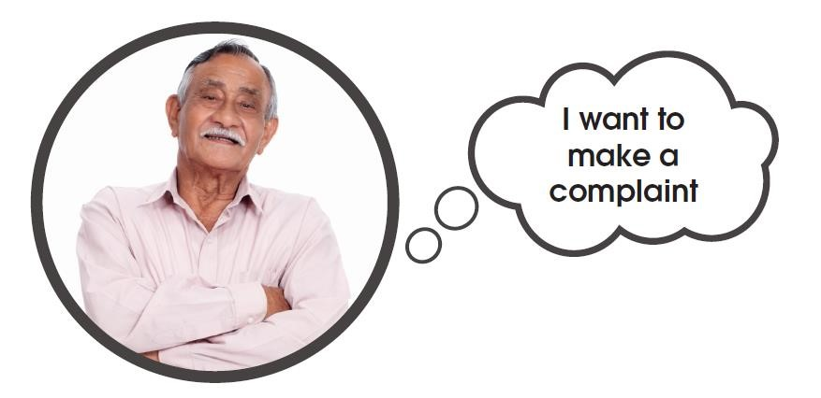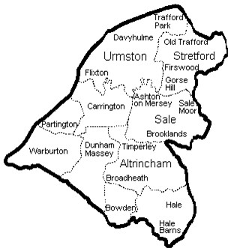

**Introduction:**

If you're not happy with any service you have had from the NHS, you can speak up about it. You also have the right to be heard and treated kindly and with respect while they help you.

Here are some things you can make a complaint about to the NHS:

  

|  |  |  |  |  |
| --- | --- | --- | --- | --- |
| **Doctors and nurses** |  | **Dentists** |  | **Hospital and staff** |

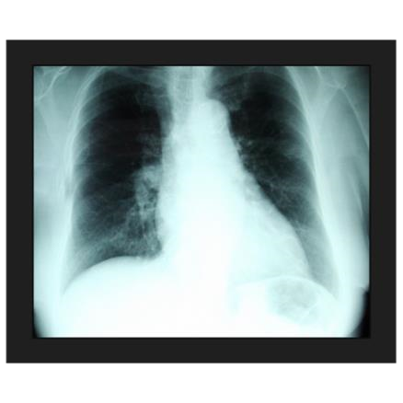 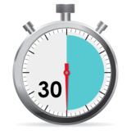

**Medication errors Misdiagnosis Waiting times**



**Care coordinators**

Speaking up about your concerns might help solve the problem or get you an explanation or an apology. Telling the NHS about your experience can also help them make care better for other people in the future.

This guide will show you, step by step, how to make a complaint. It gives you the information you need, explains your choices, and shows how someone can help. It will also help you feel more confident about speaking up.

You can make a complaint for someone else, but you’ll need their permission (unless they have passed away or can't give consent themselves).

In this guide you will find **information** and **tips** that you can look back at while going through the complaints process.

 

**How can Advocacy Focus help you with your complaint?**

Advocacy Focus is an independent, free and confidential service. This service is designed to support **anyone** who needs support to make a complaint. If you live in Trafford and need help with complaints about the NHS, we are here to guide you through the process.

**Your advocate can:**

* *Provide a confidential and independent service for you to talk about your complaint with*
* *Help you understand the different steps of the complaints process*
* *Assist you in writing any letters about your complaint*
* *Help you prepare for and attend any meetings about solving the issue*
* *Assist you in taking the complaint further if you’re not happy with the responses you get*

It's important to know that your advocate cannot tell you what to do or influence your decisions. They provide information and options, not their personal opinions. You can get support by phone, email, in person, or through a Microsoft Teams meeting at any stage of your complaint.

Our contact details are below:

**Advocacy Focus**

**Saturn House**

**Mercury Rise**

**Altham Business Park**

**BB5 5BY**

Telephone: 0300 323 0965

Text: 07886 744 634

Email: admin@advocacyfocus.org.uk

Website: [www.advocacyfocus.org.uk](http://www.advocacyfocus.org.uk/)

**Before you make your complaint:**

It's important to take time to think about exactly what you want to complain about. This could be one event or several things about your care and treatment.

The NHS ask that complaints are made as soon as possible, but no later than 12 months after the event or 12 months from when you realised you needed to make a complaint.

**As your complaint may have lots of elements to it, it may be useful to use the box below to separate each issue:**

•

•

•

•

**What do you hope to happen as a result of your complaint?**

When you make a complaint, some things you might get are:

* An explanation
* An apology
* Changes to rules or procedures

However, some things cannot happen through a complaint, like:

* Financial compensation
* Disciplinary action

If you want financial compensation, you’ll need to take legal action and speak to a solicitor. It’s important to involve them early if you go down this route.

Disciplinary action might happen after your complaint is investigated, but it’s not guaranteed. The NHS don’t have to tell you if they take disciplinary action.

It’s helpful to think about what you want to achieve and what questions you want answered before making your complaint:

|  |
| --- |
|  |

**Making a complaint:**

There are different ways to complain about the NHS, either formally or informally. If you feel comfortable, **you can talk to a staff member or their manager directly**. This is usually the quickest way to solve a problem. If you don’t feel comfortable doing this, you can talk to the Patient Advice and Liaison Service (PALS) for NHS complaints.

**What is PALS?**

 PALS offers private advice, support, and information about health issues in the NHS. They are a contact point for patients, families, and carers.

**PALS can help by:**

* Answering health-related questions
* Resolving problems when you are using the NHS
* Telling you how to get more involved in your own healthcare

**PALS can give you information about:**

* The NHS
* The NHS complaints process, including how to get independent help
* Support groups outside the NHS

**PALS also listens to your ideas to help improve the NHS.**

**Following the complaints procedures for the NHS**

You might decide that making a formal complaint is the best option if:

* You've talked to a staff member but the issue still isn’t solved
* You don’t feel comfortable speaking directly to a staff member
* You believe the complaint needs an investigation
* Your complaint has several parts to it

The NHS advise that you should complain directly to the service provider first, for example, the GP, dentist, hospital, etc. Alternatively, you can complain to the commissioners of that service – either NHS England or the areas Integrated Care Boards (ICB). In general, NHS England commissions most primary care services, such as GP’s, dental services, opticians and pharmacy services. ICB’s oversee the commissioning of secondary care, such as hospital care and some community services. If you’re not sure who to contact, you can contact NHS England (Greater Manchester) via email at [england.contactus@nhs.net](mailto:england.contactus@nhs.net) or by writing to:

3 Piccadilly Place  
London Road  
Manchester  
M1 3BN

**You can make a formal complaint to the NHS in the following ways:**

* Speaking to someone in person
* Calling on the phone
* Sending an email
* Writing a letter
* Using an online complaints form (if available)

**Template complaint letter**

If you decide to write a complaint letter, it’s a good idea to keep a copy of everything you send so you can refer to it later.

**Here is a template you can use for your complaint letter (text in ORANGE is for you to change):**

|  |
| --- |
| Your Name  Your Address  Your Mobile number  Your Email Address    Date      The Complaints Manager  Name of the organisation or trust  Address of the organisation      **PRIVATE AND CONFIDENTIAL**    To Whom It May Concern (or Dear [Name] if you know it),    I am writing to complain about the treatment I received from [name of staff or people involved] at [name of the service or the place where the incident happened] on [date of incident or time period].    • Put bullet points here if you like or a paragraph on what happened.    Now describe what happened, when and where. The more specific your information the easier it will be for the Complaints Team to deal with your complaint.    Explain what you have done, if anything, to attempt to resolve the issue already. For example, this could be a direct conversation you have had with the member of staff involved. Try to include dates, names and locations where you can. |
| I would like you to respond to the following points of my complaint:    1. Put here all the specific points that you are unhappy with, with the most important first.  2.  3.    In your response, I would like you to answer the following questions I have:    1. Here you should ask specific questions you would like answered about the incident or the treatment you are unhappy with.  2.  3.    As a result of this complaint, I would now like (this is where you put the outcome you want to achieve):    For example   1. An explanation of what happened and why 2. An apology 3. Action to remedy the problem or change things so that this does not happen again in the future     I would be grateful if you would please carry out a full investigation into my concerns and provide me with a response in line with the NHS Complaints Procedure.      Yours sincerely or Yours faithfully  Yours sincerely should be used if you know the name of the contact and yours faithfully if you do not.    Your signature    Print your name    If you would like other people to receive the response also, put this here cc. [Name]  [Name of service and address here] |

**What happens next?**

* You should get a reply to let you know they've received your complaint within three working days. This letter will tell you roughly how long it will take to look into and answer your complaint. It may also ask you to contact them again if you haven’t heard back by then.
* By the deadline, you should get a response to your complaint. This response should answer your questions and say if they can do what you asked. If you don’t get an answer by the deadline, you can send another letter or make a phone call.
* If you’re unhappy with their response, you can write another letter explaining why or ask for a meeting to talk things over.

If you ask for a meeting, you should explain which problems you think haven’t been fixed yet. You can ask for the meeting over the phone, by email, letter, in person, or on Microsoft Teams. People from the NHS will meet with you, and you can bring someone with you if you want. They should offer a date and time that works for you.

**If you feel you don’t have a family member or friend to support you in this meeting, or if you think having an advocate would be better, please contact Advocacy Focus at 0300 323 0965.**



**Resolution meetings:**

A resolution meeting gives the organisation a chance to answer your questions and provide more information or explanations in person or via Microsoft Teams. These meetings can feel a bit worrying, so here are some things you might want to discuss:

**Have to hand:**

* A list of issues you want to talk about
* The outcomes you hope to achieve from discussing these issues. Remember, having more than one outcome may improve your chances of getting what you want.

Be prepared to wait for a response after the meeting, especially if they need to investigate further.

While resolution meetings can seem intimidating, they are usually friendly, and the people leading the meeting have a lot of experience.

**What happens during a resolution meeting?**

* The NHS department running the meeting will start by introducing everyone. This helps you know who’s in the meeting and what their role is.
* During the meeting, each problem or question should be discussed. You can also bring up any new questions that come up as you talk.
* At the end of the meeting, some or all of your issues should be addressed. If not, the NHS might need more time to investigate. You can ask for a follow-up letter or another meeting if it helps.
* Once everything is finished, you’ll get a letter or an invite to another meeting explaining the decisions made on your issues.

**If you feel that your complaint hasn’t been handled properly, you can take it to the Parliamentary and Health Service Ombudsman.**

**The Parliamentary and Health Service Ombudsman (PHSO):**

If your complaint is about an NHS-funded service and wasn’t resolved at the local resolution meeting, you have the right to appeal to the Parliamentary and Health Service Ombudsman (PHSO). However, the PHSO will only investigate your case if you have first tried to resolve the issue locally.

It's important to remember that while the PHSO looks at every individual case sent to them, they are not required to investigate all of them.

You should submit your complaint to the PHSO **no later than one year after the event** or incident you are complaining about, or from when you first became aware of the issue. There are some situations where this rule may not apply, such as if you were unwell or if the local resolution took more than a year.

**The PHSO has changed how they handle complaints about the NHS** and now focuses mainly on more serious cases. Their approach is:

* They will look at all complaints made to them.
* They will try to resolve your complaint quickly if they can.
* If they can’t resolve it quickly and think the impact on you was relatively minor, they will inform you that they will not be taking it further.
  + The PHSO defines “relatively minor” as:
    - Annoyance, frustration, worry, or inconvenience—usually from a one-off incident.
    - A small amount of distress or minor pain that lasts a short time.

The PHSO is unlikely to look at complaints about:

* Delays in complaint responses
* Issues that are likely to resolve themselves in a few weeks or months
* Non-critical delays in service delivery caused by organisations dealing with COVID-19
* If you want to discuss your complaint before submitting it, the PHSO has a helpline. You can call them at:

**0345 015 4033**

**8:30 am - 5:30 pm, Monday to Friday**

You can submit your complaint to the PHSO through this link: <https://www.ombudsman.org.uk/>

On their website, you can access their complaints form and find a guide on how to fill it out. They also have a helpline and easy-read and large-print documents available for download. If you don’t have a computer and need support with this, please contact Advocacy Focus to speak with an advocate.

**The PHSO Process:**

|  |
| --- |
| **Step 1:**    When the Ombudsman receives your complaint, they will first check if it is eligible. They will look at two things:   * Whether they can investigate the organisation you are complaining about. * Whether you have gone through the complaints process of that organisation.   The PHSO receives many complaints each year, and about 25% of these move on to the next stage. If they can't take your complaint further, they will provide you with information about what you can do next. |

|  |
| --- |
| **Step 2:**    When the PHSO is deciding whether to investigate your complaint further, they will consider:   * Whether you were personally affected by what happened. * Whether you complained (to them or an MP) within a year of knowing about the issue. * Whether you had the option to take legal action instead. * Whether there are signs that the organisation may have made a mistake that negatively affected you and hasn’t been corrected. * The severity of the impact your complaint had on you and whether they can resolve it quickly.   **Timescale:**  The PHSO states that there is currently about a 7-month wait before they can look at your complaint and decide whether to investigate.  The PHSO reviews thousands of complaints each year at this stage and investigates about half of them. If they choose not to investigate your complaint, they will explain why and let you know about any other options available to you. |

**Step 3:**

The next stage in the process is for the PHSO to complete an investigation of your complaint. An Ombudsman representative will be assigned to your case. They will discuss your concerns with you and explain what they will be investigating. They will also tell you how long they think the investigation will take and keep you updated throughout the process.

The representative will gather all the necessary information from you and the organisation you complained about before making a final decision.

If the PHSO upholds your complaint, it means they have found that the organisation made mistakes that negatively affected you and haven’t been corrected. They can recommend actions for the organisation to take to address these issues.

Each year, the PHSO investigates many complaints and upholds about **50%** of them, either fully or partially.

The PHSO will write a report about your investigation and will keep you updated on when it will be ready to share with you and the organisation you complained about, so you’ll know what to expect. If they need more information while writing the report, they will reach out to you.

This report is called a "**draft report**." It won't be finalised until you and the organisation you complained about have had a chance to give your comments and feedback. The draft report will outline the results of the investigation, the initial conclusions, and the information used to reach those conclusions.

The draft report should clearly explain:

* **What happened**
* **What should have happened**
* **Whether the organisation made mistakes**
* **Whether those mistakes negatively affected you (or other people) or caused suffering**
* **Whether or not the situation has been corrected**

Once the PHSO has considered all feedback and completed any necessary additional work, they will finalise the report and send it to you, the organisation, and any other involved parties.

If the PHSO has made recommendations for the organisation, the report will clearly state what actions they expect the organisation to take and by when. They will check to ensure the organisation follows through on these actions and will keep you updated.

This marks the end of the investigation stage. The PHSO will invite you to provide feedback on the investigation, which helps them understand what they are doing well and how they can improve their service. They will also let you know how to challenge their decision if you believe they made a mistake, such as overlooking important information when reaching their decision.