

A guide to making an NHS or Social Care complaint
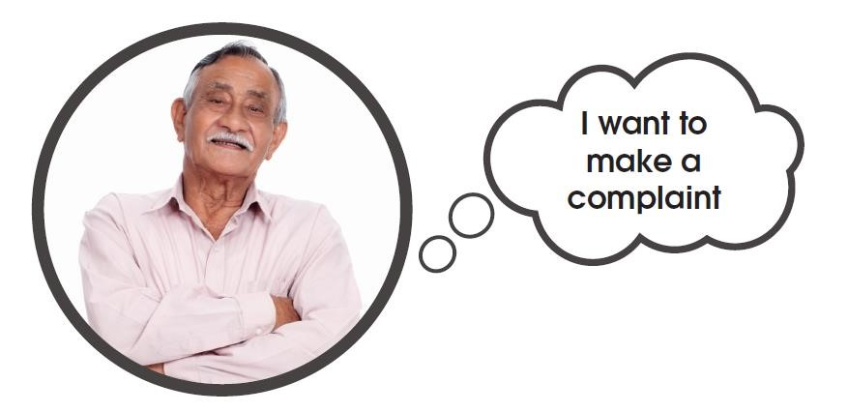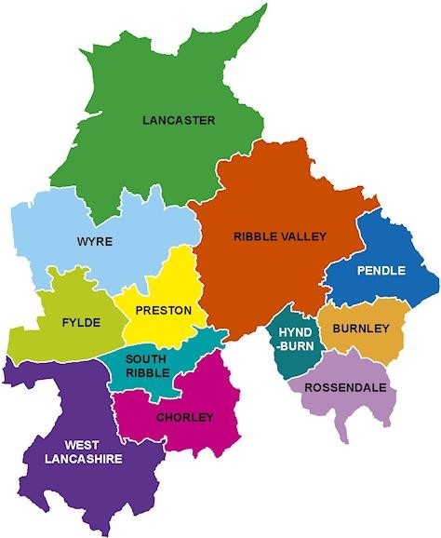

Introduction:

If you're not happy with any service you have had from the NHS or Social Care, you can speak up about it. You also have the right to be heard and treated kindly and with respect while they help you.

Here are some things you can make a complaint about to the NHS or Social Services:
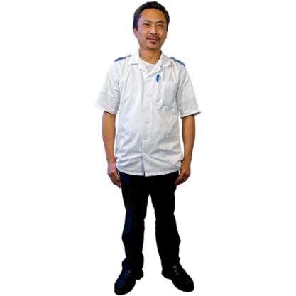
Doctors and nurses |  | Dentists |  | Hospital and staff
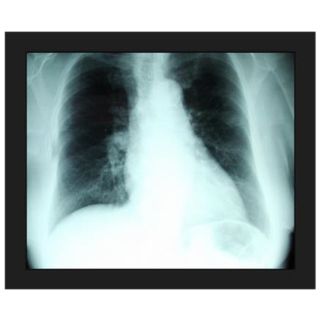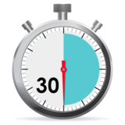

Medication errors Misdiagnosis Waiting times

Care providers
and care homes Social workers | Care coordinators

Speaking up about your concerns might help solve the problem or get you an explanation or an apology. Telling the NHS or Social Services about your experience can also help them make care better for other people in the future.
This guide will show you, step by step, how to make a complaint. It gives you the information you need, explains your choices, and shows how someone can help. It will also help you feel more confident about speaking up.
You can make a complaint for someone else, but you’ll need their permission (unless they have passed away or can't give consent themselves).
In this guide you will find information and tips that you can look back at while going through the complaints process.



How can Advocacy Focus help you with your complaint?

Advocacy Focus is an independent, free and confidential service. This service is designed to support anyone who needs support to make a complaint. If you live in Lancashire and need help with complaints about the NHS or Social Care, we are here to guide you through the process.
Your advocate can:
- Provide a confidential and independent service for you to talk about your complaint with
- Help you understand the different steps of the complaints process
- Assist you in writing any letters about your complaint
- Help you prepare for and attend any meetings about solving the issue
- Assist you in taking the complaint further if you’re not happy with the responses you get

It's important to know that your advocate cannot tell you what to do or influence your decisions. They provide information and options, not their personal opinions. You can get support by phone, email, in person, or through a Microsoft Teams meeting at any stage of your complaint.

Our contact details are below:

Advocacy Focus
Saturn House
Mercury Rise
Altham Business Park
BB5 5BY

Telephone: 0300 323 0965
Text: 07886 744 634
Email: admin@advocacyfocus.org.uk
Website: www.advocacyfocus.org.uk


Before you make your complaint:

It's important to take time to think about exactly what you want to complain about. This could be one event or several things about your care and treatment.
Both the NHS and Lancashire County Council ask that complaints are made as soon as possible, but no later than 12 months after the event or 12 months from when you realised you needed to make a complaint.


As your complaint may have lots of elements to it, it may be useful to use the box below to separate each issue:
•

•

•

•

What do you hope to happen as a result of your complaint?
When you make a complaint, some things you might get are:
- An explanation
- An apology
- Changes to rules or procedures

However, some things cannot happen through a complaint, like:
- Financial compensation
- Disciplinary action


If you want financial compensation, you’ll need to take legal action and speak to a solicitor. It’s important to involve them early if you go down this route.

Disciplinary action might happen after your complaint is investigated, but it’s not guaranteed. The NHS or Social Services don’t have to tell you if they take disciplinary action.

It’s helpful to think about what you want to achieve and what questions you want answered before making your complaint:

Making a complaint:

There are different ways to complain about the NHS, either formally or informally. If you feel comfortable, you can talk to a staff member or their manager directly. This is usually the quickest way to solve a problem. If you don’t feel comfortable doing this, you can talk to the Patient Advice and Liaison Service (PALS) for NHS complaints.

What is PALS?


PALS offers private advice, support, and information about health issues in the NHS. They are a contact point for patients, families, and carers.

PALS can help by:
- Answering health-related questions
- Resolving problems when you are using the NHS
- Telling you how to get more involved in your own healthcare
PALS can give you information about:
- The NHS
- The NHS complaints process, including how to get independent help
- Support groups outside the NHS

PALS also listens to your ideas to help improve the NHS.

Following the complaints procedures for the NHS and Lancashire County Council (LCC):

You might decide that making a formal complaint is the best option if:
- You've talked to a staff member but the issue still isn’t solved
- You don’t feel comfortable speaking directly to a staff member
- You believe the complaint needs an investigation
- Your complaint has several parts to it
The NHS suggests that you first complain directly to the service provider, such as your GP, dentist, or hospital. If you prefer, you can complain to the commissioners of the service, like NHS England or the area's Integrated Care Board (ICB). NHS England handles most GP, dental, optician, and pharmacy services, while ICBs manage hospital care and some community services. If you're unsure who to contact, you can call NHS England (Lancashire) at 01772 420150 or email england.contactus@nhs.net.

You can make a formal NHS complaint by:
- Speaking to someone in person
- Calling on the phone
- Sending an email
- Writing a letter
- Using an online complaints form (if available)

For a formal complaint about Lancashire County Council (LCC), you can:
- Visit Compliments, comments or complaints - Lancashire County Council and use their online form
- Call 0300 123 6720
- Email complaintsandfeedback@lancashire.gov.uk
- Write a letter and post it to:
Complaints and appeals team
Legal and Democratic Services
County Hall
Fishergate
Preston
PR1 8XJ

Template complaint letter

If you decide to write a complaint letter, it’s a good idea to keep a copy of everything you send so you can refer to it later.


Here is a template you can use for your complaint letter (text in ORANGE is for you to change):

Your Name
Your Address
Your Mobile number
Your Email Address

Date

The Complaints Manager
Name of the organisation or trust
Address of the organisation

PRIVATE AND CONFIDENTIAL

To Whom It May Concern (or Dear [Name] if you know it),

I am writing to complain about the treatment I received from [name of staff or people involved] at [name of the service or the place where the incident happened] on [date of incident or time period].

• Put bullet points here if you like or a paragraph on what happened.

Now describe what happened, when and where. The more specific your information the easier it will be for the Complaints Team to deal with your complaint.

Explain what you have done, if anything, to attempt to resolve the issue already. For example, this could be a direct conversation you have had with the member of staff involved. Try to include dates, names, and locations where you can.

I would like you to respond to the following points of my complaint:

1. Put here all the specific points that you are unhappy with, with the most important first.
2.
3.

In your response, I would like you to answer the following questions I have:

1. Here you should ask specific questions you would like answered about the incident or the treatment you are unhappy with.
2.
3.

As a result of this complaint, I would now like (this is where you put the outcome you want to achieve):

For example
- An explanation of what happened and why
- An apology
- Action to remedy the problem or change things so that this does not happen again in the future

I would be grateful if you would please carry out a full investigation into my concerns and provide me with a response in line with the NHS Complaints Procedure.

Yours sincerely or Yours faithfully
Yours sincerely should be used if you know the name of the contact and yours faithfully if you do not.

Your signature

Print your name

If you would like other people to receive the response also, put this here cc. [Name]
[Name of service and address here]

What happens next?

- Whether your complaint is to the NHS or Lancashire County Council (LCC), you should receive a letter acknowledging your complaint within three working days. This letter will let you know how long it might take to investigate and respond to your complaint. It will usually ask you to get in touch if you haven’t heard from them by that time.
- By the end of the deadline, you should get a response to your complaint letter. Their response should address the issues you raised and explain if they can meet your expected outcomes. If you don’t receive a response by then, it’s okay to send another letter or make a phone call.
- If you disagree with their response, you can write back with your concerns about their answer, or you can ask for a resolution meeting.
When you request a resolution meeting (by phone, email, letter, in person, or via Microsoft Teams), you should explain the issues that you feel have not been resolved. This meeting will involve the people from the NHS or LCC related to your complaint. You don’t have to attend this meeting alone; they will offer you a time and date that works for you.

If you feel you don’t have a family member or friend to support you in this meeting, or if you think having an advocate would be better, please contact Advocacy Focus at 0300 323 0965.



Resolution meetings:

A resolution meeting gives the organisation a chance to answer your questions and provide more information or explanations in person or via Microsoft Teams. These meetings can feel a bit worrying, so here are some things you might want to discuss:
Have to hand:
- A list of issues you want to talk about
- The outcomes you hope to achieve from discussing these issues. Remember, having more than one outcome may improve your chances of getting what you want.

Be prepared to wait for a response after the meeting, especially if they need to investigate further.
While resolution meetings can seem intimidating, they are usually friendly, and the people leading the meeting have a lot of experience.

What happens during a resolution meeting?
- The meeting will be led by someone from the NHS or Lancashire County Council. They should introduce everyone, so you know who is in the meeting and what their roles are.
- Each unresolved issue or outcome will be discussed during the meeting. You will also have the chance to ask any additional questions that come up.
- By the end of the meeting, some or all of your issues may be addressed. If not, the NHS or Lancashire County Council might need to investigate further. You can ask for a letter to be written or for another resolution meeting if that would be easier for you.
- After the meeting, you will receive a letter or an invitation to a further meeting explaining the issues discussed and the decisions made as a result of any further investigation.

If you feel that your complaint hasn’t been handled properly, you can take it to the Parliamentary and Health Service Ombudsman or the Local Government Ombudsman, depending on who your complaint is about.

The Parliamentary and Health Service Ombudsman (PHSO):

If your complaint is about an NHS-funded service and wasn’t resolved at the local resolution meeting, you have the right to appeal to the Parliamentary and Health Service Ombudsman (PHSO). However, the PHSO will only investigate your case if you have first tried to resolve the issue locally.

It's important to remember that while the PHSO looks at every individual case sent to them, they are not required to investigate all of them.

You should submit your complaint to the PHSO no later than one year after the event or incident you are complaining about, or from when you first became aware of the issue. There are some situations where this rule may not apply, such as if you were unwell or if the local resolution took more than a year.

The PHSO has changed how they handle complaints about the NHS and now focuses mainly on more serious cases. Their approach is:

- They will look at all complaints made to them.
- They will try to resolve your complaint quickly if they can.
- If they can’t resolve it quickly and think the impact on you was relatively minor, they will inform you that they will not be taking it further.
  - The PHSO defines “relatively minor” as:
    - Annoyance, frustration, worry, or inconvenience—usually from a one-off incident.
    - A small amount of distress or minor pain that lasts a short time.

The PHSO is unlikely to look at complaints about:

- Delays in complaint responses
- Issues that are likely to resolve themselves in a few weeks or months
- Non-critical delays in service delivery caused by organisations dealing with COVID-19
- If you want to discuss your complaint before submitting it, the PHSO has a helpline. You can call them on:

0345 015 4033
8:30 am - 5:30 pm, Monday to Friday

You can submit your complaint to the PHSO through this link: https://www.ombudsman.org.uk/

On their website, you can access their complaints form and find a guide on how to fill it out. They also have a helpline and easy-read and large-print documents available for download. If you don’t have a computer and need support with this, please contact Advocacy Focus to speak with an advocate.

The PHSO Process:

Step 1:

When the Ombudsman receives your complaint, they will first check if it is eligible. They will look at two things:

- Whether they can investigate the organisation you are complaining about.
- Whether you have gone through the complaints process of that organisation.

The PHSO receives many complaints each year, and about 25% of these move on to the next stage. If they can't take your complaint further, they will provide you with information about what you can do next.

Step 2:

When the PHSO is deciding whether to investigate your complaint further, they will consider:

- Whether you were personally affected by what happened.
- Whether you complained (to them or an MP) within a year of knowing about the issue.
- Whether you had the option to take legal action instead.
- Whether there are signs that the organisation may have made a mistake that negatively affected you and hasn’t been corrected.
- The severity of the impact your complaint had on you and whether they can resolve it quickly.

Timescale:
The PHSO states that there is currently about a 7-month wait before they can look at your complaint and decide whether to investigate.

The PHSO reviews thousands of complaints each year at this stage and investigates about half of them. If they choose not to investigate your complaint, they will explain why and let you know about any other options available to you.

Step 3:

The next stage in the process is for the PHSO to complete an investigation of your complaint. An Ombudsman representative will be assigned to your case. They will discuss your concerns with you and explain what they will be investigating. They will also tell you how long they think the investigation will take and keep you updated throughout the process.

The representative will gather all the necessary information from you and the organisation you complained about before making a final decision.

If the PHSO upholds your complaint, it means they have found that the organisation made mistakes that negatively affected you and haven’t been corrected. They can recommend actions for the organisation to take to address these issues.

Each year, the PHSO investigates many complaints and upholds about 50% of them, either fully or partially.

The PHSO will write a report about your investigation and will keep you updated on when it will be ready to share with you and the organisation you complained about, so you’ll know what to expect. If they need more information while writing the report, they will reach out to you.

This report is called a "draft report." It won't be finalised until you and the organisation you complained about have had a chance to give your comments and feedback. The draft report will outline the results of the investigation, the initial conclusions, and the information used to reach those conclusions.

The draft report should clearly explain:

- What happened
- What should have happened
- Whether the organisation made mistakes
- Whether those mistakes negatively affected you (or other people) or caused suffering
- Whether or not the situation has been corrected

Once the PHSO has considered all feedback and completed any necessary additional work, they will finalise the report and send it to you, the organisation, and any other involved parties.

If the PHSO has made recommendations for the organisation, the report will clearly state what actions they expect the organisation to take and by when. They will check to ensure the organisation follows through on these actions and will keep you updated.

This marks the end of the investigation stage. The PHSO will invite you to provide feedback on the investigation, which helps them understand what they are doing well and how they can improve their service. They will also let you know how to challenge their decision if you believe they made a mistake, such as overlooking important information when reaching their decision.

The Local Government Ombudsman (LGO):

The Local Government Ombudsman is the final step for complaints about councils and some other organisations that provide local public services. They handle complaints about adult social care providers, like care homes and home care services.
The LGO advises that you should complete all stages of the organisation’s complaints process first. If your complaint hasn’t been resolved, or you haven’t received a response in a reasonable amount of time, you can take your complaint to the LGO.
Again, you need to submit your complaint no later than one year after the event or incident you are complaining about, or from when you first became aware of the issue. There are some exceptions to this rule, such as if you were unwell or if the local resolution took longer than a year.
The LGO is more likely to investigate complaints where the issues:
- Have had a serious or long-term impact on people’s lives.
- Affect many other people.
They are less likely to investigate complaints where:
- The issues have caused only minor irritation or upset.
- They cannot ask the organisation to do what you want.
You can file a complaint with the LGO using this link:
http://www.lgo.org.uk/
They also have a helpline if you want to discuss your complaint before submitting it:
0300 061 0614
8:30 am – 5:00 pm, Monday to Friday
On their website, you can find their complaints form and a guide on how to complete it. If you don’t have access to a computer and need support, please contact Advocacy Focus to speak with an advocate.

The LGO Process:

Step 1:

First, the Local Government Ombudsman (LGO) will confirm that they have received your complaint. If they need more information at this point, they will reach out to you using the details you provided.

If you have already complained directly to the organisation involved, their Assessment Team will determine whether they should investigate your complaint further. The LGO will send you a letter explaining the outcome of this decision. They aim to decide whether your complaint will be investigated within four weeks.

Step 2:

If the Local Government Ombudsman (LGO) decides that your complaint needs more detailed review, they will pass it to the Investigation Team. You will be informed about the person who is handling your complaint. The LGO may reach out to you or the organisation for more information.

When the LGO believes they have enough information to make a fair decision, they will share a draft decision with you. They usually provide copies of the information that the organisation has given them, but sometimes sensitive information cannot be shared.

The LGO will then give you one last chance to comment or provide any additional information you want them to consider before they make a final decision. After the final decision is made, the LGO will write to you to explain their reasons. They will also send a copy of the decision to the organisation you complained about.

LGO decisions are final, but there are procedures in place if you wish to challenge their decision or make a complaint about the service they provided.

Timescale: The LGO states that it is hard to say how long the investigation will take since every complaint is different. The whole process can take many months from start to finish.

